Software Requirements Specification Template

Indian Student Association - NMWSU

Software Requirements Specification

Version – 1.7

Friday, August 21, 2020

Team Members:
Bharat Reddy Male
Bhavya Deepthi Gorrepati
Mahalakshmi Kongari
Sai Jyothsna Mathi
Jeevan Reddy Mure
Dheeraj Edupuganti

Submitted in partial fulfillment
Of the requirements of
CSIS 44-691 Graduate Directed Project 1

Revision History

Date | Description | Author | Comments
June’09,2020 | Version – 1.0 | Team | Initial Document
June’10,2020 | Version – 1.1 | Team | Updated Design Draft
June’10,2020 | Version – 1.2 | Team | Updated document with ER-Diagram
June’11,2020 | Version – 1.3 | Team | Updated document with mock-ups
June’16,2020 | Version – 1.4 | Team | Functional requirements updated as per client request
June’29,2020 | Version – 1.5 | Team | Added Technical Manual chapter
June’30,2020 | Version – 1.6 | Team | Added End User Manual chapter
Aug’21,2020 | Version – 1.7 | Team | Added project objectives

Document Approval

The following Software Requirements Specification has been accepted and approved by the following:
Signature | Printed Name | Title | Date

Table of Contents

Table of Contents Page Number

- Introduction
  - Purpose
  - Scope
  - Definitions, Acronyms, and Abbreviations
  - References
  - Overview
- General Description
  - Product Perspective
  - Product Functions
  - User Characteristics
  - General Constraints
  - Assumptions and Dependencies
- Specific Requirements
  - External Interface Requirements
    - User Interfaces
    - Hardware Interfaces
    - Software Interfaces
    - Communications Interface
  - Functional Requirements
  - Use Cases
  - Class/Objects
  - Non-Functional Requirements
3.5.1. Performance
3.5.2. Reliability
    - Availability
    - Security
    - Portability
  - Inverse Requirements
  - Design Constraints
  - Logical Database Requirements
  - Other Requirements
  - Prototypes (for complete project)
  - Use Case Diagrams
- Design
4.1. ER diagram
4.2. GUI
- Analysis Models
5.1. Data Flow Diagram
5.2. Sequence Diagram
- Technical Manual

  - Setting up the environment
  - User Interface
  - Validation
  - Database Schema
  - Routes and Request Handling
- End User Manual
  - Login Screen
  - Registration Screen
  - Forgot Password Screen
  - Home Screen

- Introduction
  - Purpose: The purpose of this document is to present a detailed description of the Indian Student Association – NWMSU, a website that is intended to help the Indian community studying at Northwest Missouri State University. This website will be used to inform the community about the events being held by ISA, the team will be able to better manage the requests of the students and have a better interaction with them during a pandemic situation.
Objectives:
- The project will help Team ISA to manage events and other activities
- The project will help the Indian community to better reach the ISA team and know about the upcoming events.
- The pickup/ accommodation facilities provided by Team ISA is a complex thing now. The project would make it simpler.
- Uses will have a chat and forum feature to post queries and chat with the ISA team
  - Scope: This application will be a web-based application for the Indian community studying at Northwest Missouri State University. The system will be designed to help the user to:
    - Register with ISA
    - Request Airport rides
    - View upcoming events hosted by ISA
    - Contact ISA for any issues
    - Give feedback to ISA, etc.
  - Definitions, Acronyms, and Abbreviations:
Term | Definition
ISA | Indian Students Association (ISA) is a recognized organization in the university. It is headed by Sai Narneni
IDE | An integrated development environment (IDE) is a software application that provides comprehensive facilities to computer programmers for software development.
Database | Collection of all the information monitored by this system.
GUI | A GUI (graphical user interface) is a system of interactive visual components for computer software
User | A person who accesses the application
Data breach | A data breach is an incident that exposes confidential or protected information
Malware | Malware is the collective name for several malicious software variants, including viruses, ransomware, and spyware
CRUD | In computer programming, create, read, update, and delete are the four basic functions of persistent storage.
HTML | Hypertext Markup Language (HTML) is the standard markup language for documents designed to be displayed in a web browser
Captcha | A CAPTCHA is a type of challenge-response test used in computing to determine whether or not the user is human.

  - References:
- ISA - Northwest Missouri State University

  - Overview: In the next section, the general description you will find an overview of the functionality of the product. It describes the general factors that affect the product and its requirements and is used to establish a context for the technical requirements specification.
The third section, specific requirements, of this document, is written primarily for the developers and describes technical terms, the details of the functionality of the product. This subsection of the SRS will list each of the factors that affect the requirements stated in the SRS.
The fourth and fifth section of this document provides an overview of the application’s design and analysis model.
- General Description
  - Product Perspective: This website is mainly targeted on the Indian community that is willing to join Northwest Missouri State University. The ISA team will use this website as a commonplace for responding to queries and requests from students. It would also be used to manage the events that the team hosts.
  - Product Functions: The website will have the following functionalities:
    - Login
    - Registration
    - Event creation
    - Pickup monitoring
    - Chatbox
    - Help(Contact Us, Alumni, FAQ)
    - Temporary accommodation
  - User Characteristics: There would be two types of users that would be using this application. The ISA team and normal users. The ISA team would be able to respond to user requests like pick-up, temporary accommodation, and add upcoming events, etc. The normal users would be able to request for pickup, view event details, and request for temporary accommodation, etc. everyone would be able to access the chat feature and forum, however.
  - General Constraints: Since this is a website and will mostly be accessed on a variety of devices with many kinds of browsers that are of user’s choice, the website’s performance might not be the same for everyone. Also, this being a website, users need an active internet connection for accessing it and a slower internet connection would result in performance reduction.
  - Assumptions and Dependencies: The application would not perform the same for everyone since it depends on the device capable of handling the website. The application has a dependency on an active internet connection for using it.

- Specific Requirements
  - External Interface Requirements:
    - User Interfaces: A website will be required for providing the user with an interface to perform actions on the applications.
    - Hardware Interfaces: The user can access the application on a browser either on a mobile or a computer. The data will be handled by a server hosted physically or virtually over a database.
    - Software Interfaces: An interface for the user and the system is required, the database handling software is required to manage the data of the application. An IDE is required for the development and management of the application.
    - Communications Interface: The project will be using an email-based communication system for managing user’s login, registration, and subscribed notifications.
  - Functional Requirements:
Clients Functional Requirements:
Functionalities:
Guest:
- View events
- Contact us
- Forum page
- Live chat
- Help page

Students/alumni:
- Login (sign up, sign in, password reset, logout)
- View events (upcoming/past)
- Forum page
- Live chat
- Make a request (carpool, pickup, membership, etc)
- Notification sent to ISA board
- Access to help page
- View important info
- Volunteers

ISA board:
- Login
- Event management (create, edit, delete, etc)
- View/respond requests
- Notification to a specific user
- Forum management (delete the post)
- Post important info

Requirements Description:
The application when accessed should return basic information about the University and the Organization as its home page. The page should contain a navigation bar that has an ISA logo and Northwest Missouri State University logo to the left and links to:
- Home
- Events
  - Upcoming events
  - Past events
- Services
  - Membership
  - Pickup
  - Temporary Accommodation
  - Post Arrival checklist
  - Pre Arrival checklist
  - Volunteer for pickup
- Help
  - Contact us
  - Alumni
  - FAQ
- Admin Login
- 24/7 Online Chat
- Notification
- Guest Login

- Home: This should be the main page that should be returned when the application is accessed. This page should contain a carousel of Indian culture as its background. The carousel should be followed by information about the college and the organization. The footer should contain links to social media profiles of the organization and the university, etc.
- Events: This page displays past and upcoming events held by team ISA. The navigation bar for “events” contains a sub-menu of links to past and upcoming events.
  - The past events page returns the details, sponsors, and images captured during a past event.
  - The upcoming events page has details about the upcoming events that are being hosted by ISA.
- Services: The user will be provided forms to fill in their details for pickup, membership, temporary accommodation, and volunteer pickup. The data inputted in the forms will be stored at a central database for CRUD operations.
  - Pickup form: Users need to fill in their details like the first name, last name, contact no, from, to, time of arrival, number of baggage.
  - Membership form: Users need to fill in their details like the first name, last name, contact no, address, email id, degree, gender.
  - Temporary Accommodation: Users need to fill in their details like first name, last name, contact no, number of days required, gender.
  - Volunteer pickup: Users need to fill in their details like the first name, last name, contact no, number of baggage allowed.
  - Pre Arrival checklist provides necessary information and tasks to be completed by a student before they arrive at the university.
  - Post Arrival checklist provides necessary information and tasks to be completed by a student after they arrive at the university.
- Help: The user will be provided with links to pages for contact us, alumni and FAQ’s
  - Contact us: This page provides contact information about the current ISA team and a short description of them.
  - Alumni: This page provides details about the ISA alumni. This would help students get to know about their seniors and their experience at the university.
  - FAQ: This page contains frequently asked questions and answers to them.
- 24/7 Online Chat Box: This feature is an online chat 24/7 which helps users to raise their queries and get them clarified instantly.
- Notification: This feature is to send an alert to the ISA board when someone signs up for any request such as accommodation, airport pickup, etc. This also includes sending the notification alert to the specific user if the query raised by him was answered.
- Guest Login: This functionality is for the user who wants to make any request (such as accommodation, membership, airport-pickup) any to raise any queries.
- Admin Login: This functionality is only intended for the ISA team for managing the application. Post login, the team will be provided with functionalities like:
  - View pending pickup requests.
  - Add a new upcoming event.
  - Update the past events.
  - View pending temporary accommodation requests.
  - Display a list of volunteers available for pickup.
  - Update the help menu.
  - Manage the forum

  - Use cases:
  - Class/Objects:
  - Non-Functional Requirements:
    - Performance: The application should be able to respond to multiple users without having a delay and the UI should be rendered without any delay in displaying content.
    - Reliability: The application should always be available without any failures to the users for a given period.
    - Availability: The application should be available to a user at any given point i.e., even if there is a lot of load on the application due to multiple requests being handled.
    - Security: Data of the users is crucial and needs to be kept safe, the application should be safe from data breach and malware attacks and the application needs to have a way for the user to authenticate before they access the content.
    - Portability: The application should be able to adhere to different environments like mobile, desktop, tablet, etc. and should function in the same way in any browser.

  - Inverse Requirements: The application has the following inverse requirements
      - The application should not allow a user to login to it when the user-provided blank, incorrect credentials.
      - The user should not be able to access the profile of another user when he logs in using their credentials.
      - The registration functionality should not allow a user to register into the application when provided improper data.
      - The user should not complete any forms with improper/missing data.
  - Design Constraints: The application should allow non-humans to operate. A captcha mechanism should be included to avoid improper access. The GUI should be implemented in HTML.
  - Logical Database Requirements: The application should be able to perform CRUD operation across multiple tables without any data corruption.
  - Other Requirements: Computers for the team, required software licenses to be acquired, the workplace needs to be setup.
  - Prototypes (for the complete project):
  - Use Case Diagrams:

- Design:
  - ER diagram:
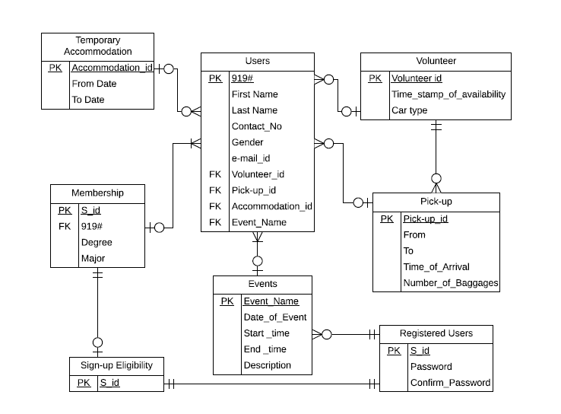

In our project, we have entities such as Volunteer, Pick-up, Temporary Accommodation, Membership, Sign-up Eligibility, Registered-users, and Events. There is a central table called Users.
Attributes of the Entities:
In the Pick-up entity, we have attributes such as Pick-up id, From, To, Time of arrival, Number of Baggage’s where the information related to the pick-up request is stored such as the user's Pick-up location(From), Destination(To), their time of arrival and number of pieces of baggage they have.
In the Temporary Accommodation entity, we have attributes such as Accommodation id, From-date, and To-date. From-date and To-date stores the information about the number of days a user requires temporary accommodation.
In the Volunteer entity, we have attributes such as, Volunteer id, Time stamp of availability which stores the information about the available time of the volunteer for pickup and car type which stores the information about the type of the car the volunteer has/uses for the pick-up.
In the Membership entity, we have attributes such as, S-id, 919#, Degree which stores the type of degree the user is pursuing and major which stores the data about the major the user is pursuing.
In the Events entity, we have attributes such as, Event Name which stores the name of the event, Date of Event, Start time, End time which stores the date, start and end time of that particular event and Description stores the data about the brief introduction on that event.
In the Sign-up Eligibility entity, we have an attribute S-id that stores the S-id’s of the current ISA team, so that it can restrict the sign-up/registration process to that particular team whose S-id’s are stored in prior on this table based on verification/validation.
In the Registered Users entity, we have attributes such as S-id, Password, and Confirm Password which stores the information to get the users to log into the portal to make any additions or modifications to the portal such as adding/modifying events.
In Users entity, we have attributes such as 919# to store the 919# of the user, First name, Last name to store the first and last names of the user, contact no, email id to store the contact number and email id of the user respectively, Gender to store the user’s gender, while the volunteer id, accommodation id, pick-up id, event name are the Primary keys of the other entities acting as foreign keys in this entity.
Relationship between Entities
In the ER diagram, considering the pickup request first, the relation from users and pick-up is optional-one and the relation from pick-up to users is optional-many. This is because the pick-up request page must be accessed by many users while each user will be allotted with the single pick-up request if needed. Same case with Temporary Accommodation and Volunteer pages. The relation between users to temporary accommodation is optional-one and the relation from temporary accommodation to users is optional many. This is because the temporary accommodation page must be accessible to all the users while a user is allotted to single accommodation if registered for.
The relation between users to volunteer is optional-one and the relation from volunteer to users is optional-many. This is because the volunteer page must be accessed by all the users while each user can sign up for a single volunteer service at a time.
The relation between pick-up to volunteer is mandatory-one and the relation from volunteer to pick-up is optional-many. This is because each pick-up is assigned with a single volunteer while each volunteer can have multiple pickups.
The relation between users to membership is optional-one and the relation from membership to users is mandatory-many. This is because all the data that the user table has need not mandatorily have the membership but the membership is open to multiple users.
The relation between Sign-up eligibility to membership is mandatory-one and the relation from membership to sign-up eligibility is optional-one. This is because all the users who have membership are not eligible for sign-up however, the people who have sign-up eligibility must have the membership.
The relation between Sign-up eligibility to registered users is mandatory-one and the relation from registered users to sign-up eligibility is mandatory-one. This is because all the people who have sign-up eligibility can be registered users and all the registered users have sign-up eligibility.
The relation between Events to registered users is mandatory-one and the relation from registered users to Events is optional-many. This is because a registered user can add/modify any number of events while each event can be added/modified by a single registered user.
The relation between Events to Users is mandatory-many and the relation from Users to Events is optional-one. This is because an event is open to any number of users at a time but a user may attend a single event at a time.

  - GUI:
The mockups for the web application are given below.
- Pre-Login Screens
- Post-Login Screens

- Pre-Login Screens:
- Login Screen: This screen is used by the user for logging into the web application. Users need to give their username, email id, and their password. Then they have to agree on the terms and conditions and on clicking the login button, the user will be logged in to the application only if the credentials are correct. The users are provided an option to reset the password if they lose it by clicking the “problems signing in?” link.
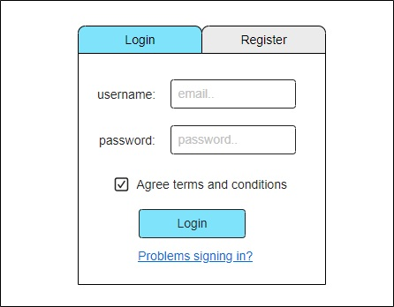
- Register Screen: This screen is used for registering with ISA. The users have to fill in the details required and click on the register button for registration. This page only registers the user if all the fields are correctly filled or else an error will be prompted to the user with what went wrong.
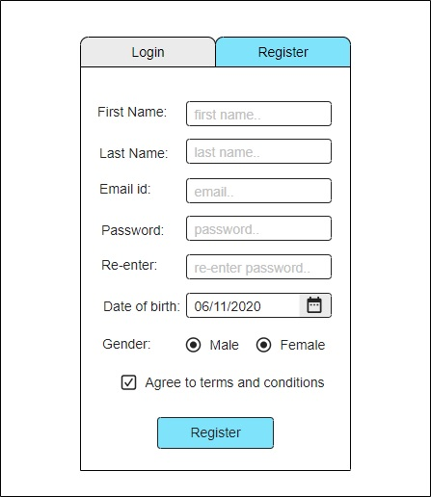

- Navigation bar item – HOME Screen → this is the main home page of the website.
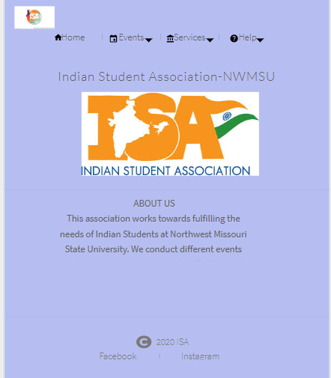
- Navigation bar item – EVENTS
Under the Events navigation item, we have two screens, Up-coming events, and Past Events.
- Up-Coming Events Screen: This screen displays the Up-coming events of ISA with brief information on the event such as the date and place of the event.
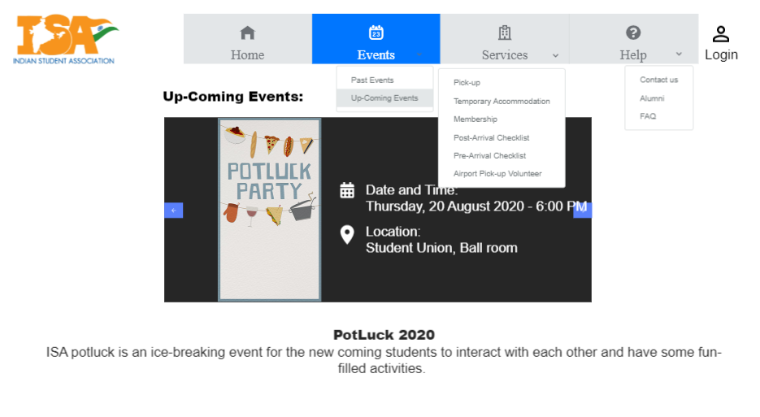

- Past Events Screens: This screen displays the past events of ISA.
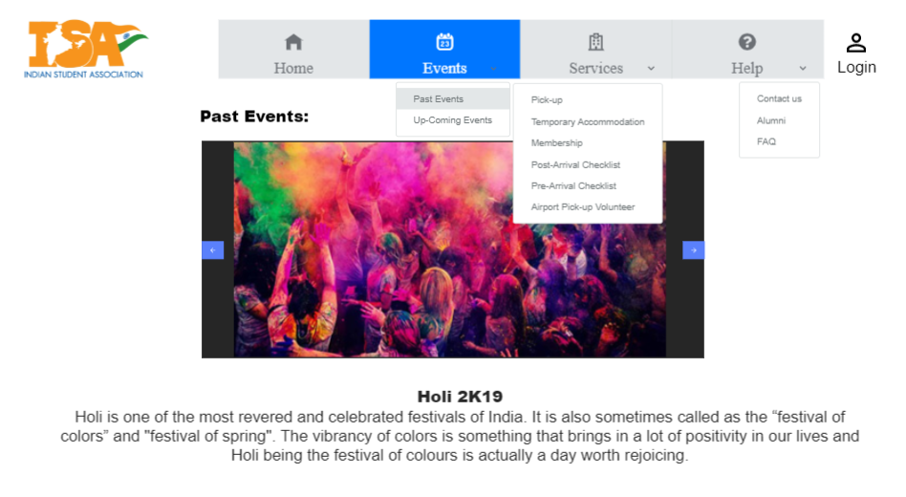

- Navigation bar item – SERVICES
Under Services navigation item, we have services such as Pick-up, Temporary Accommodation, Membership, Post-Arrival Checklist, Pre-Arrival Checklist, and Pick-up Volunteer.
- Pick-up Screen: This screen provides the user with a form to fill-up and request for the pick-up.
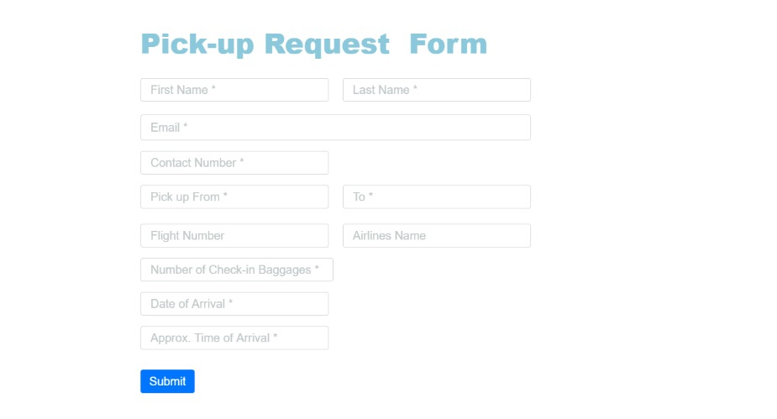
- Temporary Accommodation Screen: This screen provides the user with a request form to fill-up and can register for the temporary accommodation.
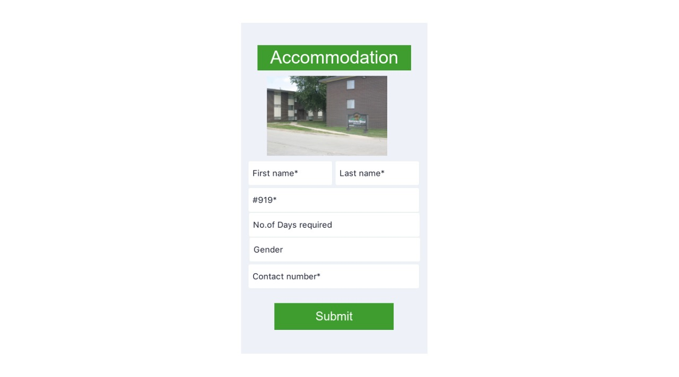

- Membership Screen: This screen provides a form which upon filling gets the ISA membership.
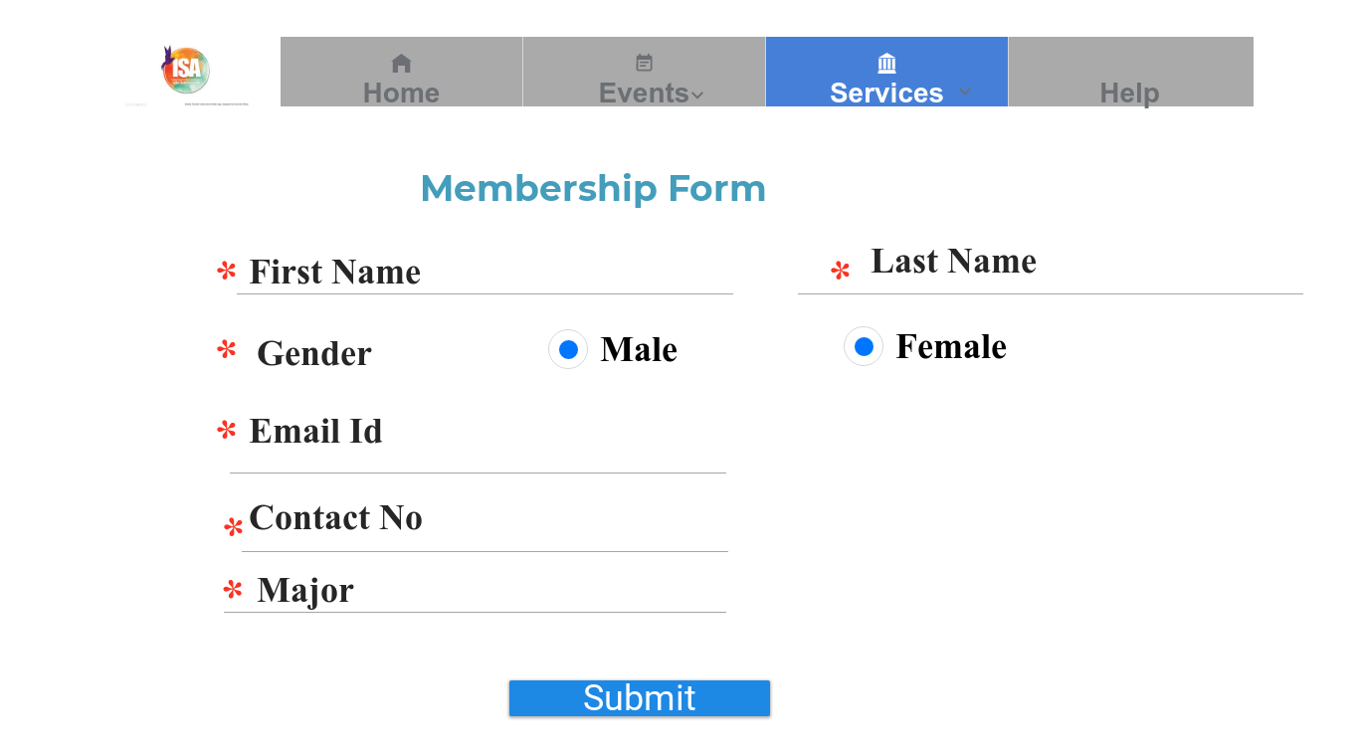

- Post-Arrival Checklist Screen: This screen provides a checklist and instructions to be followed after their arrival for the new-comers.
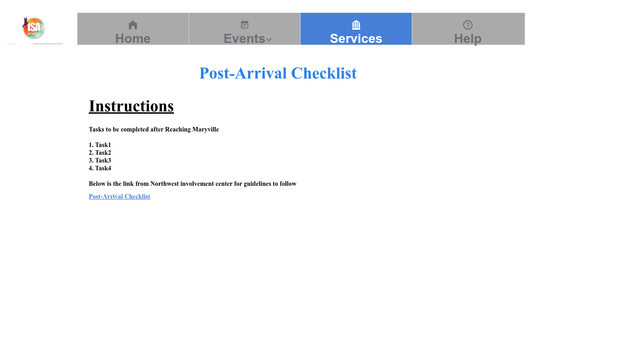

- Pre-Arrival Checklist Screen: This screen provides a checklist and instructions to be followed before their arrival for the new-comers.
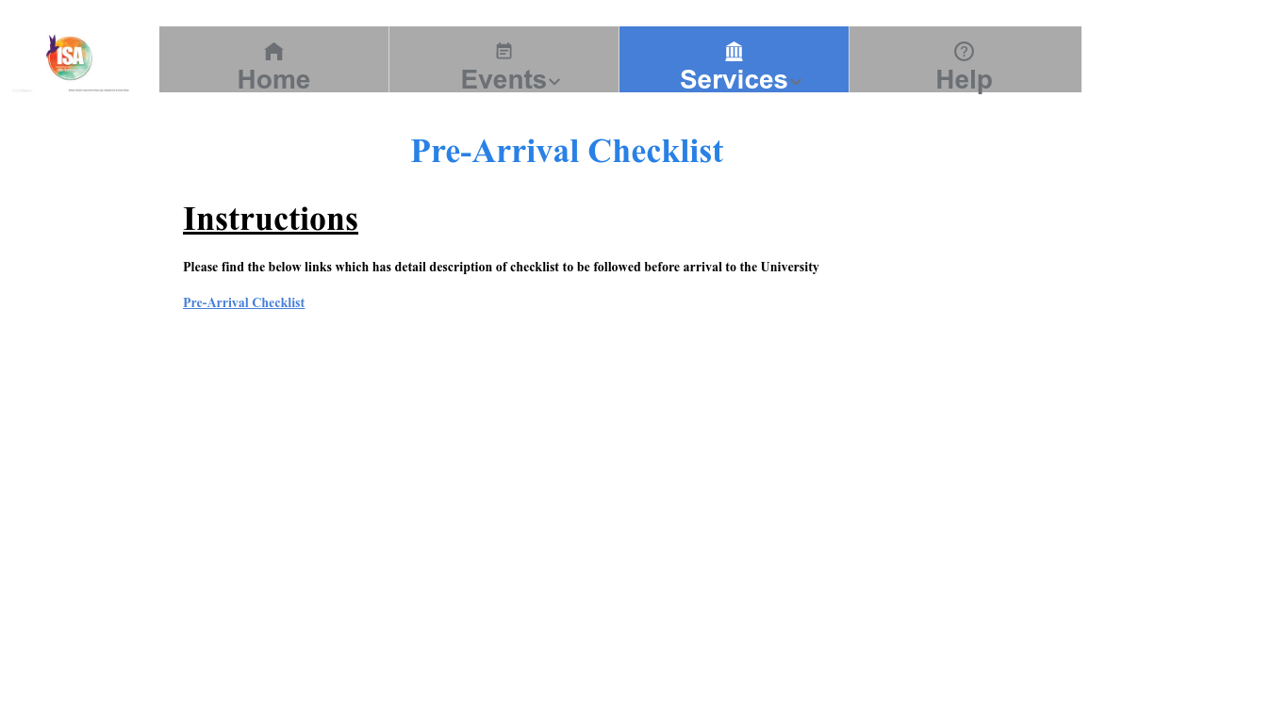
- Pick-up Volunteer: This screen provides the user with a form to fill-up and can enroll for the voluntary pick-up.

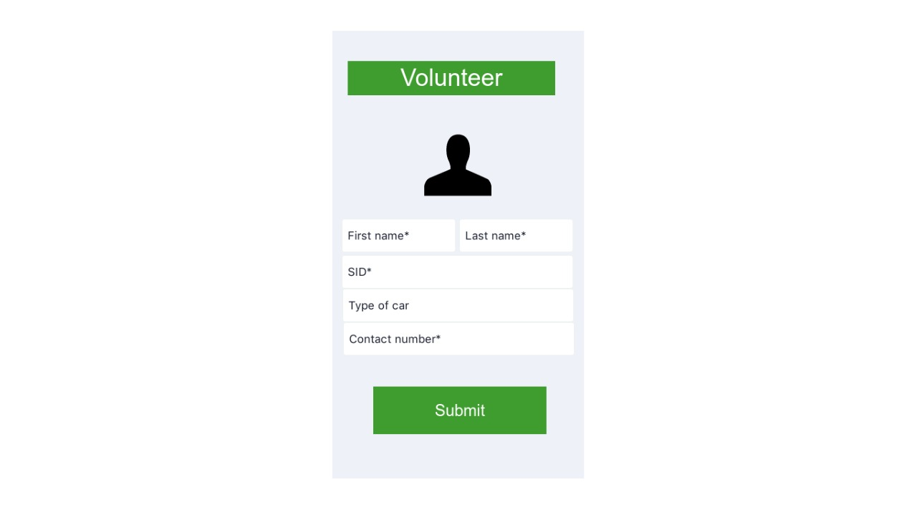

- Navigation bar item – HELP
Under Help Navigation item, we have screens such as Contact us, Alumni, and FAQ.
- Contact us Screen: This screen provides the data about the current ISA panel with their contact information.
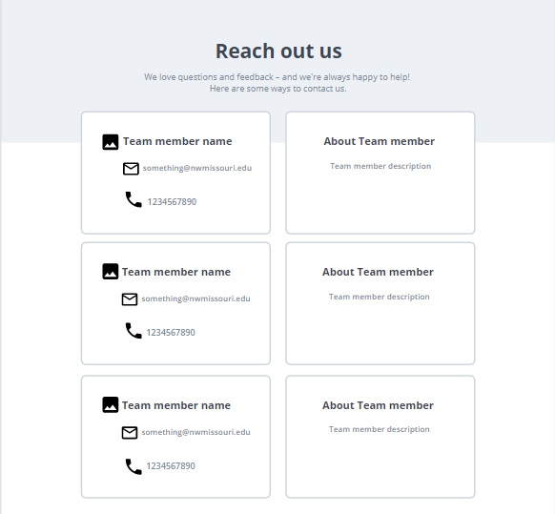

- Alumni Screen: This screen provides the data about the former ISA panel with their contact information.
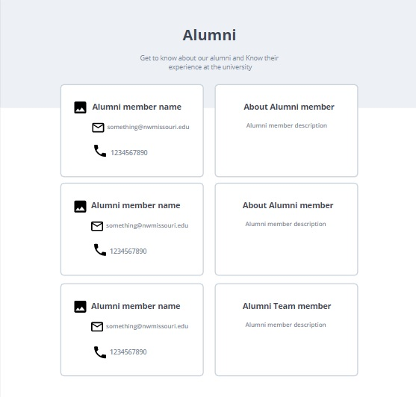

- FAQ Screen: This screen provides FAQ’s related to various topics that would help the newly-coming students.
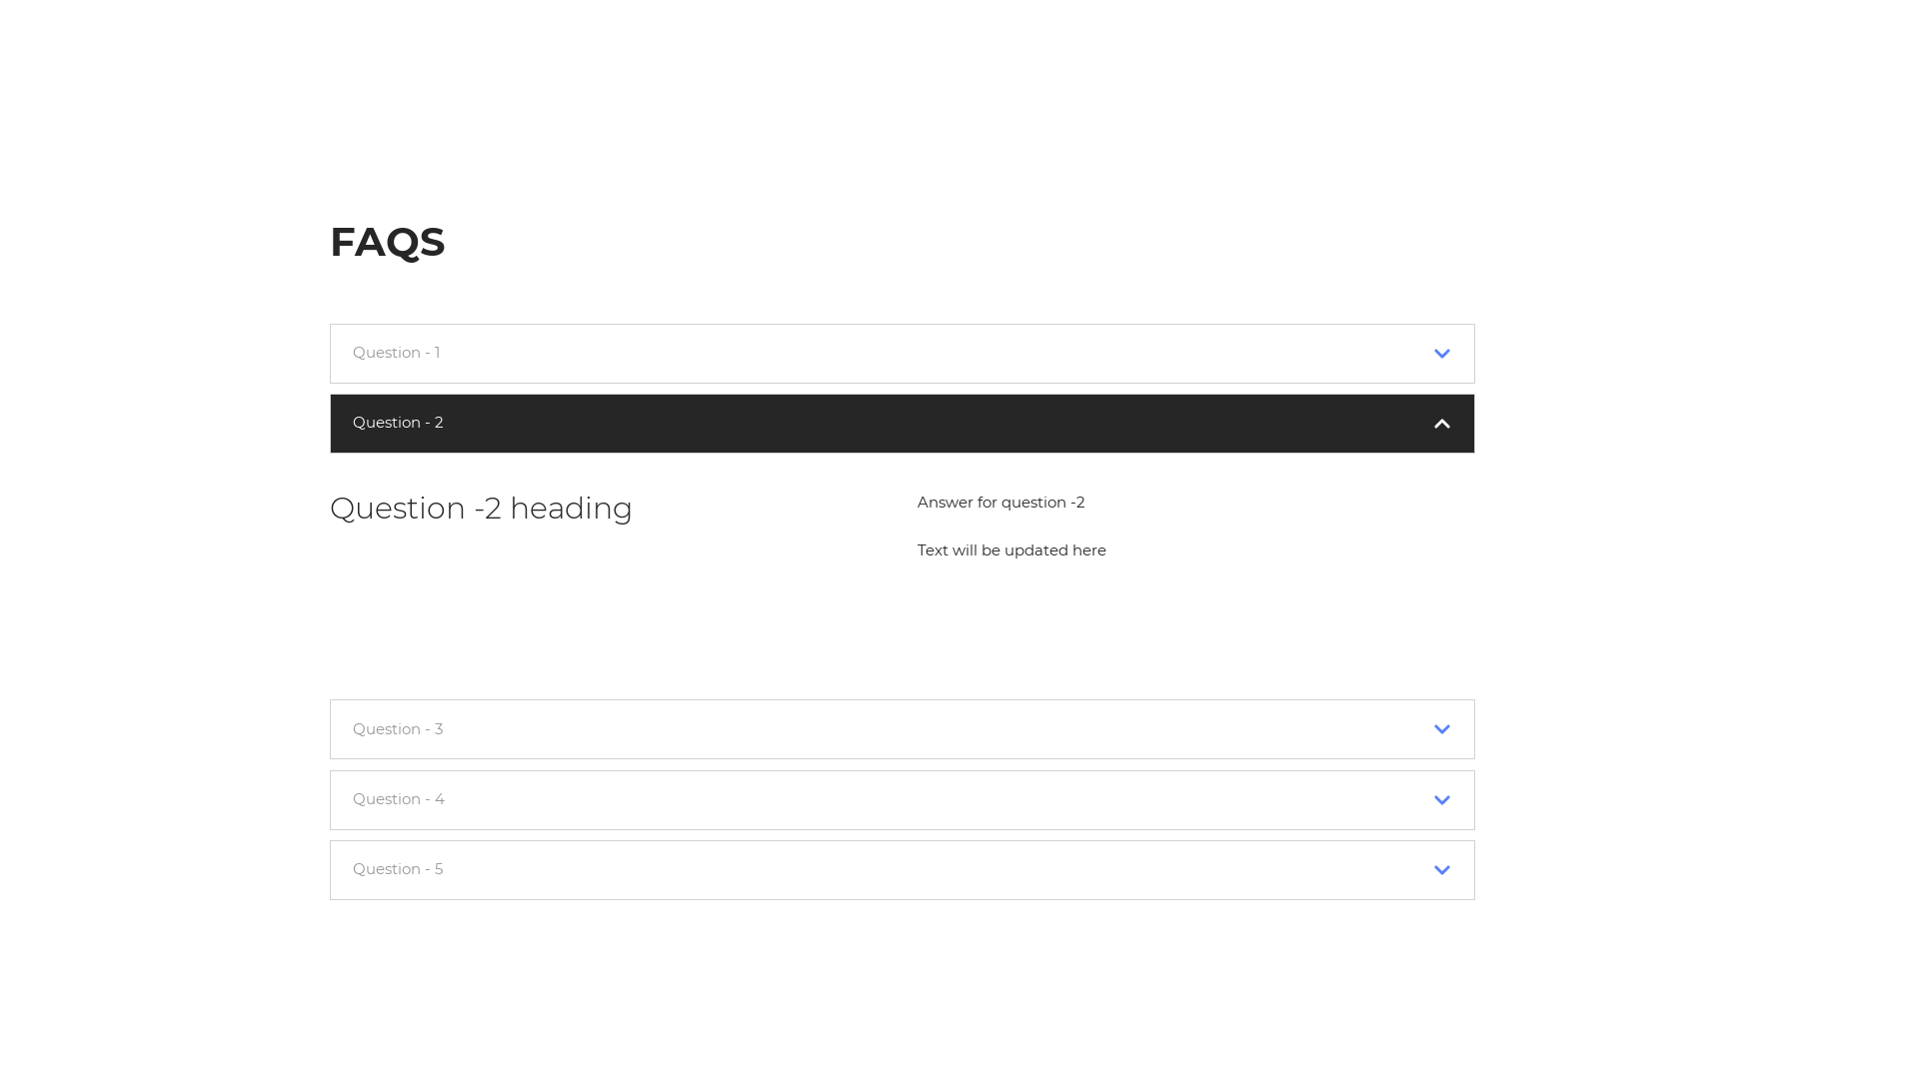
There is also a chat feature which looks as follows:
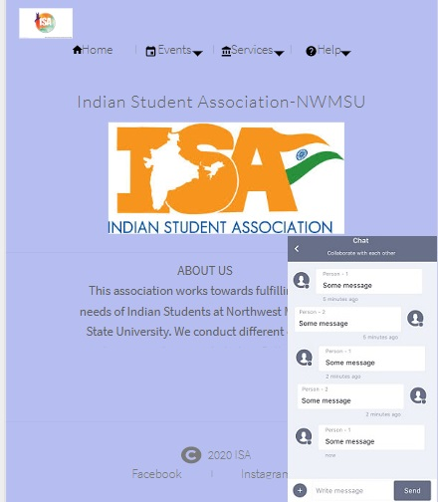

- Post-Login Screens:
- Events Screen: This screen helps the ISA team to manage or modify the events.
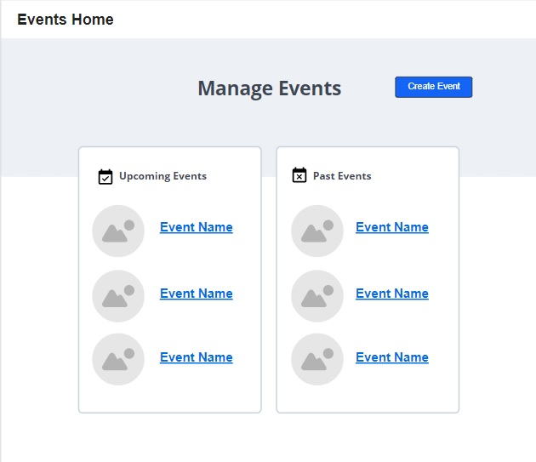

- Create Events Screen: This screen helps the ISA team to create or add a new event to the website.
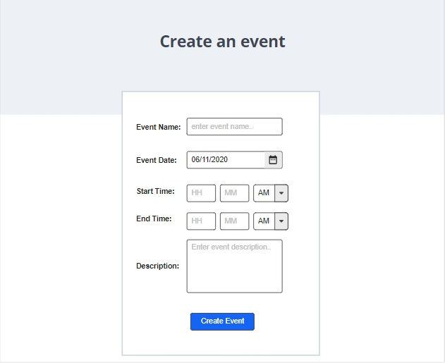
- Pick-up data Screen: This screen shows the data of the users who have filled the pick-up request form, to the ISA team.
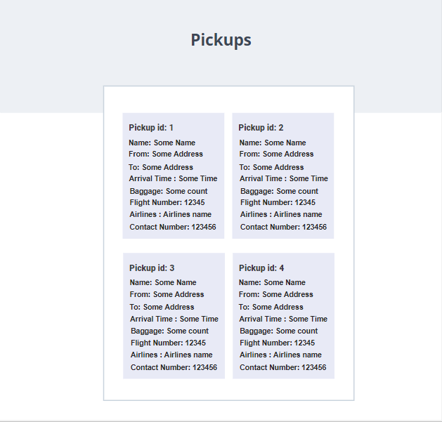
- Pick-up Volunteer data Screen: This screen shows the data of the users who have filled the pick-up volunteer form, to the ISA team.
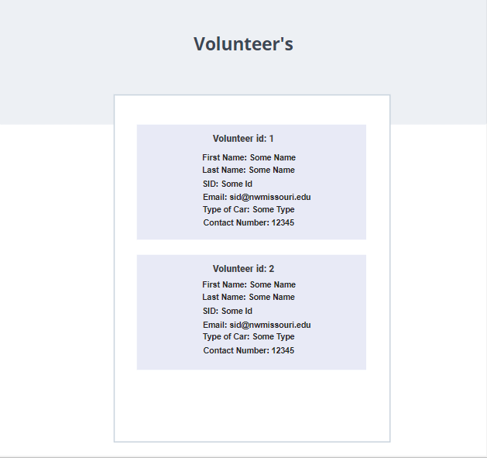
- Accommodation data Screen: This screen shows the data of the users who have filled the temporary accommodation form, to the ISA team.
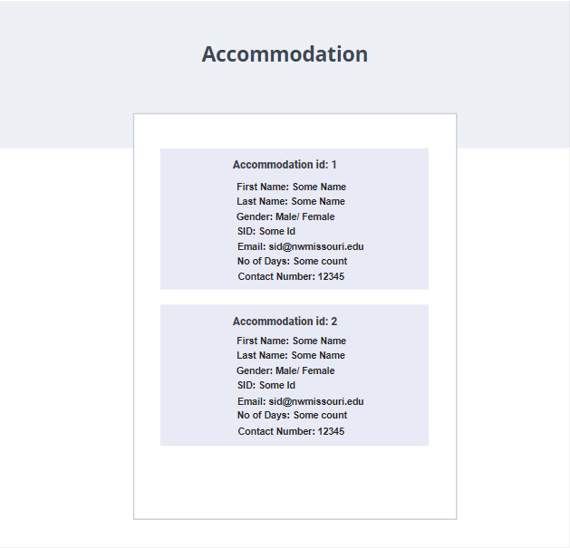

- Chatbox data Screen: This screen shows the data of the messages from the chatbox feature.
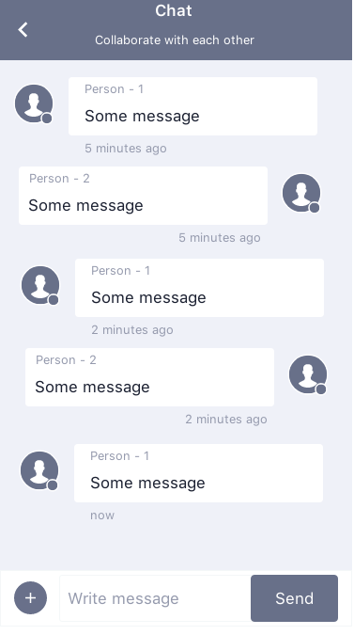

- Analysis Models:
  - Data Flow Diagram:
  - Sequence Diagram:

- Technical Manual
  - Setting up the environment: To make the application up and running there are a few pre-requisites to be performed.
    - Install the latest version of Node LTS.
    - Install Visual Studio Code.
    - Clone the application repository using Git tools like tortoise Git or GitHub desktop from
    - Open power shell and Go to the "GDP_Team-4_Section-2\Codes\isa_nwmsu" directory and run "npm install". This will install dependencies for setting up a server environment.
    - Open another power shell Go to the "GDP_Team-4_Section-2\Codes\isa_nwmsu\client" directory and run "npm install". This will install dependencies for setting up the client environment.
    - Install the React Developer tools extension onto Google Chrome.
    - Install the Redux DevTools extension onto Google Chrome.
    - Open power shell and Go to the "GDP_Team-4_Section-2\Codes\isa_nwmsu" directory and run "npm start". This will start the server on port 5000.
    - Open another power shell Go to the "GDP_Team-4_Section-2\Codes\isa_nwmsu\client" directory and run "npm start". This will start the client on port 3000.
  - User Interface: A common Navigation Bar is applied to every page of the application it is created using bootstrap CSS and HTML. The UI looks like below for the navigation bar.
The code for this navigation bar is available in the “GDP_Team-4_Section-2\Codes\isa_nwmsu\client\src\components\layout\Navbar.js” file and it looks like below.
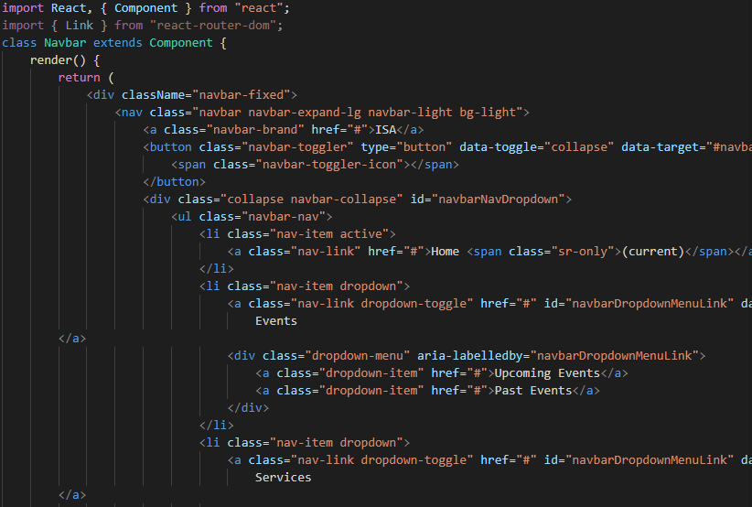
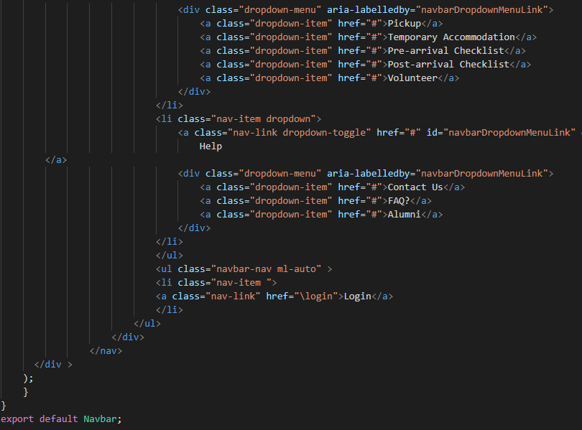
    - Login Interface: This page serves as the applications login page and has input fields for username and password, a login button, links for navigating back to home, registration page, and forgot password. This page is created using HTML and material-CSS and Bootstrap. The code for the login page can be found at “GDP_Team-4_Section-2\Codes\isa_nwmsu\client\src\components\auth\Login.js”.
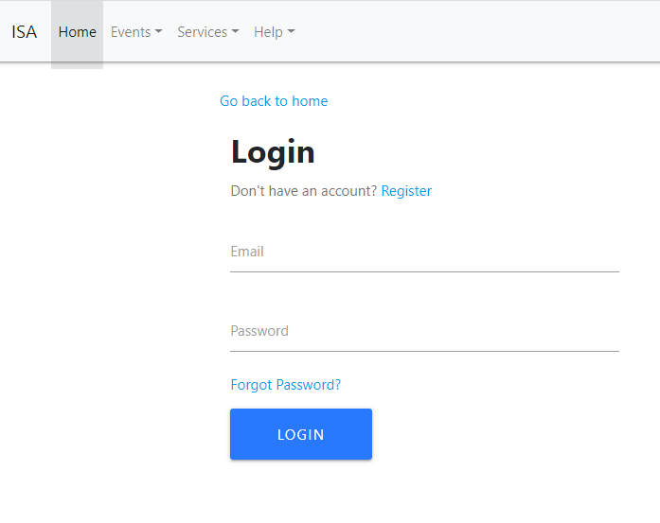
The code in the file looks like the below screenshot. This code is responsible for taking the user input in the fields of email and password and validations are in place for improper input.
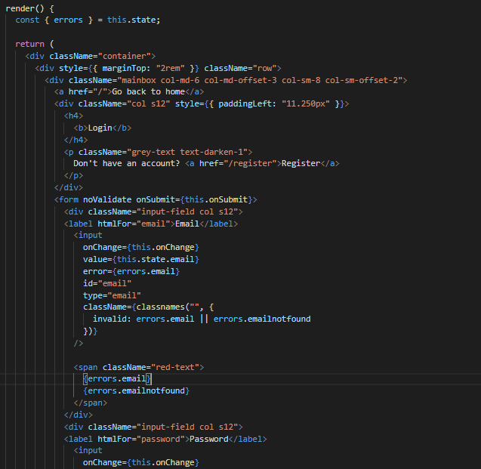

- Registration Interface: This page serves as the applications registration page and has input fields for Name, email, password, and confirm password, a sign-up button, and links for navigating back to home, login page. This page is created using HTML and material-CSS and Bootstrap.
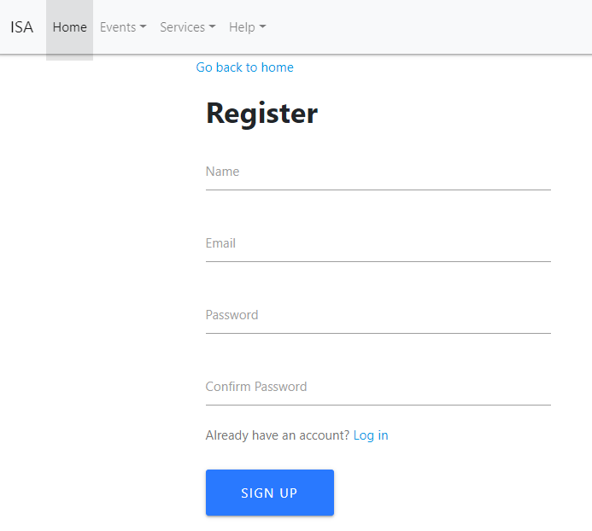
The code for the registration page can be found at “GDP_Team-4_Section-2\Codes\isa_nwmsu\client\src\components\auth\Register.js”. This code is responsible for taking the user input in the fields of Name, email, and password and confirm password.

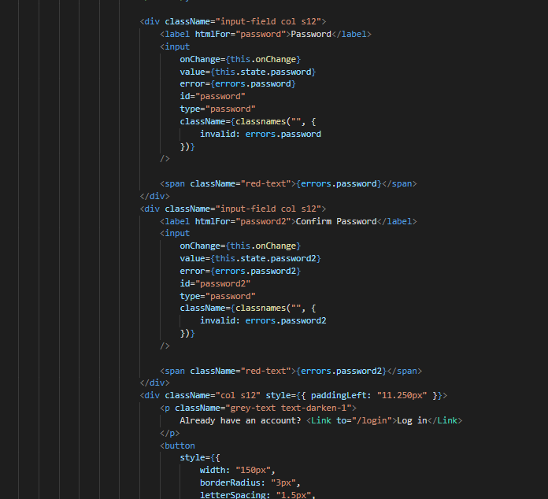

- Forgot Password Interface: This page is responsible for letting users reset their password and the UI is written in HTML and styling is done using Material-CSS and Bootstrap. The page looks like below
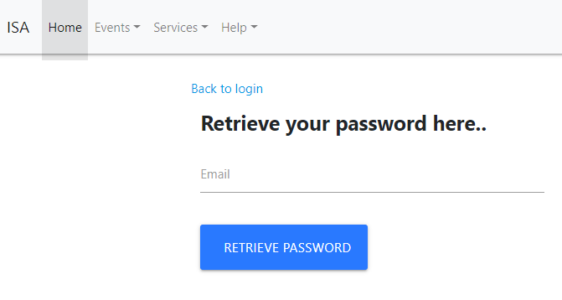
This page has fields for entering email and the retrieve password button and a link to navigate back to home. When the retrieve password button is clicked, the data is sent to the database for validation and the password is reset. The code for the UI is available at “GDP_Team-4_Section-2\Codes\isa_nwmsu\client\src\components\auth\ForgotPassword.js”.
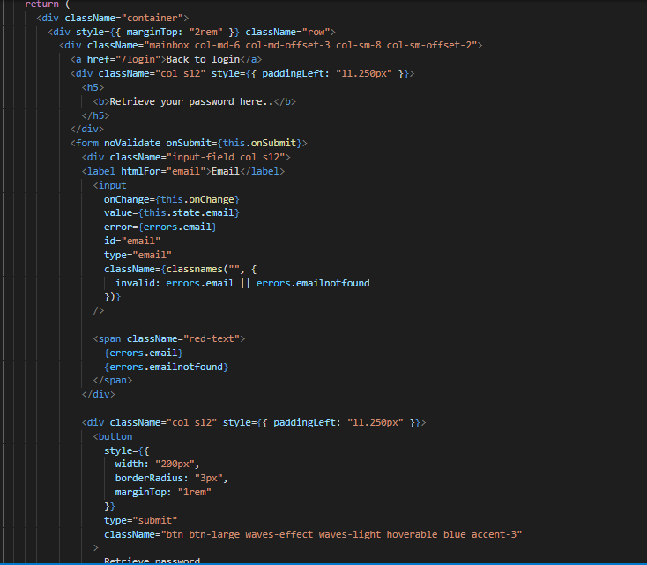
- Home Interface: This page is presented to the user after the user successfully login’s to the application with the correct credentials. This page is created using HTML and Material-CSS and Bootstrap. The code for this page is available at “C:\Users\s537359\Documents\GDP\GDP_Team-4_Section-2\Codes\isa_nwmsu\client\src\components\home\home.js” and the sample code and UI looks like below.
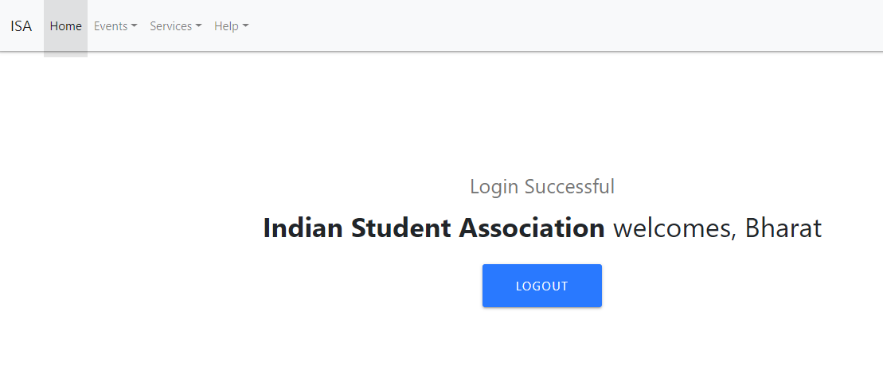
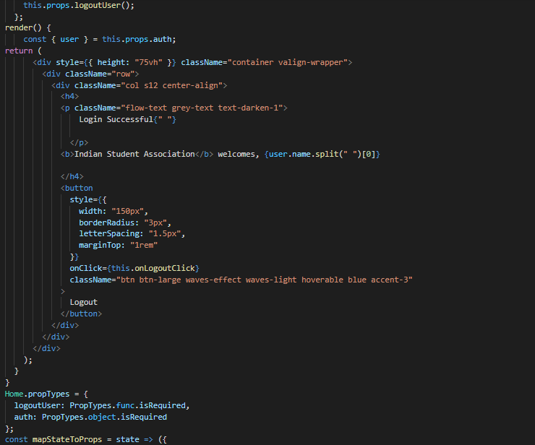

  - Validations: Each page for the login functionality has validations in place the checks for user input. The validations are for checking:
    - If the fields are empty.
    - Email follows a proper format.
    - Password field and confirm password field contain the same data.
    - If an email is already in the database.
    - If the user provides the correct password for login, etc.

The validation for the login page is available at “C:\Users\s537359\Documents\GDP\GDP_Team-4_Section-2\Codes\isa_nwmsu\validation\login.js” and is responsible for checking if the user has given some data or if the field is empty. It also checks if the credentials are correct or else it will throw errors.

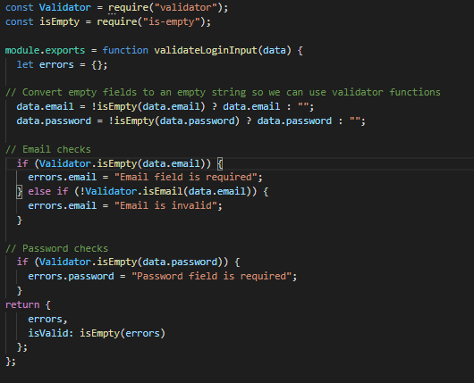

The validation for the Registration page is available at “C:\Users\s537359\Documents\GDP\GDP_Team-4_Section-2\Codes\isa_nwmsu\validation\register.js” and is responsible for checking if the user has given some data or if the field is empty. It also checks if the email is already used and if the password and confirm password fields are matching.
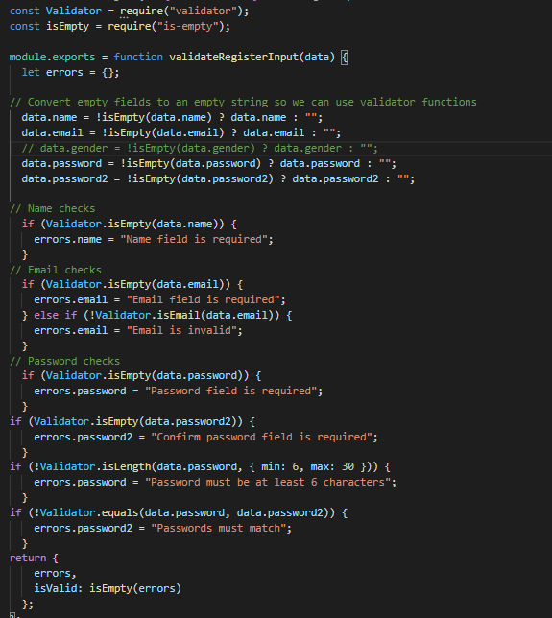

The validation for forgot password page is available at “C:\Users\s537359\Documents\GDP\GDP_Team-4_Section-2\Codes\isa_nwmsu\validation\ForgotPassword.js” and is responsible for checking if the user has given some data or if the field is empty. It also checks if the email is already available in the database or not.
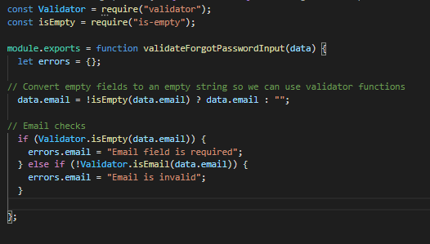

  - Database Schema: The Login functionality is managed by the database schema available at “GDP_Team-4_Section-2\Codes\isa_nwmsu\models\User.js”. This schema has 5 required entities.
    - Name of type string and is required.
    - Email of type string and is required.
    - Password of type string and is required.
    - Data of type date and defaults to the current timestamp when a user is registered.

The data is stored in MongoDB atlas cloud in a database named isa-nwmsu and the collection named users.
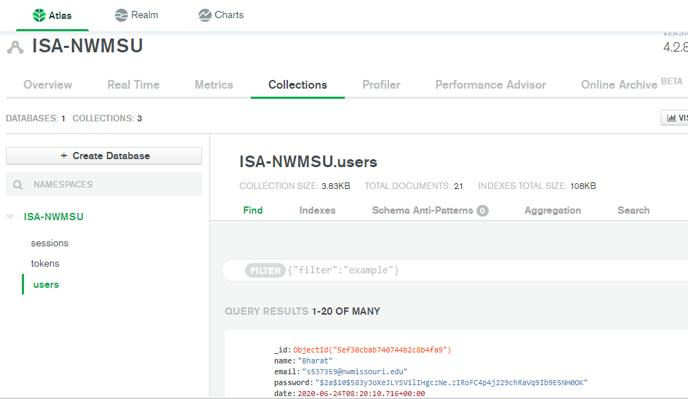
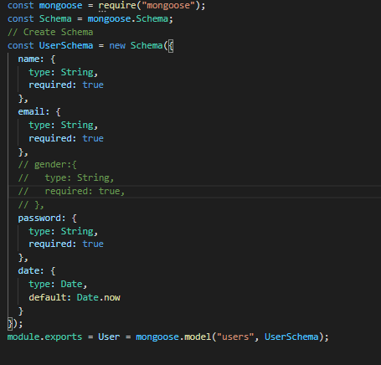

  - Routes and Request Handling: There are multiple routes for the application to handle user requests. The codes for routes are available at “GDP_Team-4_Section-2\Codes\isa_nwmsu\routes\api\users.js”.

    - /register route
    - /login route
    - /forgotpassword route

The register route is responsible for managing the user request for registration. This route first checks if the user input is valid when the signup button is clicked, then it checks if there is any user with the same email already in the database and if there are no users with the same email then, it hashes the user password using the bcrypt module into non-human readable format and creates a new user schema and saves it to the database. If there are any errors during this process, this route throws an error to the user stating what went wrong. The code for the same is mentioned below.

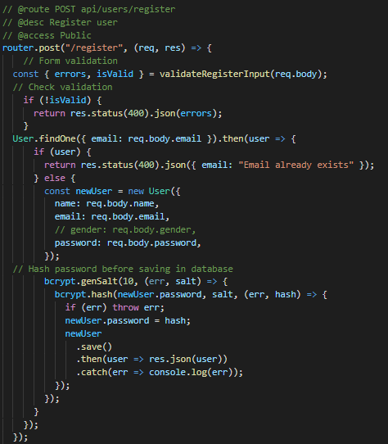

The Login route is responsible for letting the user login to the system. This route handles the /login of the application and when the user clicks the login button, this route first checks if the user input is valid and then checks if the user’s email is available in the database. Then the password is compared with the hashed password using the bcrypt module and if everything is fine then the user is logged onto the application. This route is also responsible for creating a JWT token in the user’s browser which has a validity of 1 year. This token helps the user maintain his login session even if the page reloads.

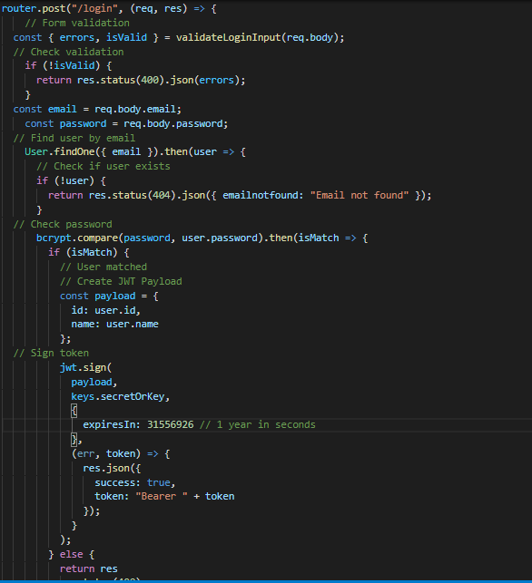

The \forgotpassword route is responsible for managing the forgot password functionality of the application and when a user clicks retrieve password, the routs validates and responds to the user if the email is correct with further instructions for resetting their password.

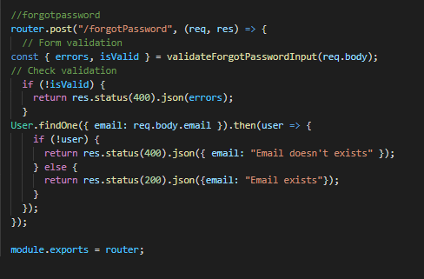

The request handling for the login functionality is available at “C:\Users\s537359\Documents\GDP\GDP_Team-4_Section-2\Codes\isa_nwmsu\client\src\actions\authActions.js”. This code is responsible for letting the router know when and what to be called. This acts as an interface between the routes and UI.

When a login request is posted, the login route is called and if there are no errors, the local storage of the browser is updated with a JWT token.

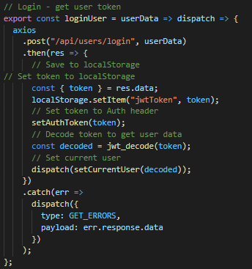

When a registration request is posted, the register route is called and if there are no errors, the user data is stored into the database by the register route and the login page is pushed to the user.

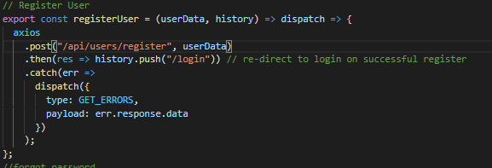

- End User Manual
Indian Strudent Association-NWMSU is a web application that is mainly targeted on the Indian community that is willing to join Northwest Missouri State University. The ISA team will use this website as a commonplace for responding to queries and requests from students. It would also be used to manage the events that the team hosts.

  - Login Screen: This page is called the login page where a user will be able to perform a login operation onto the application. The user has fields for entering email and password and a login button which, when clicked performs the login operation. The user should make sure the credentials provided are correct or else they will be shown an error which is easy to understand.
This page also has a link to navigate back home and a link to register if the user doesn’t have an accout already. They are also provided with an option to retrieve their password by clicking the forgot password button. The user will be able a screen which is shown below and errors in user input is also attached.
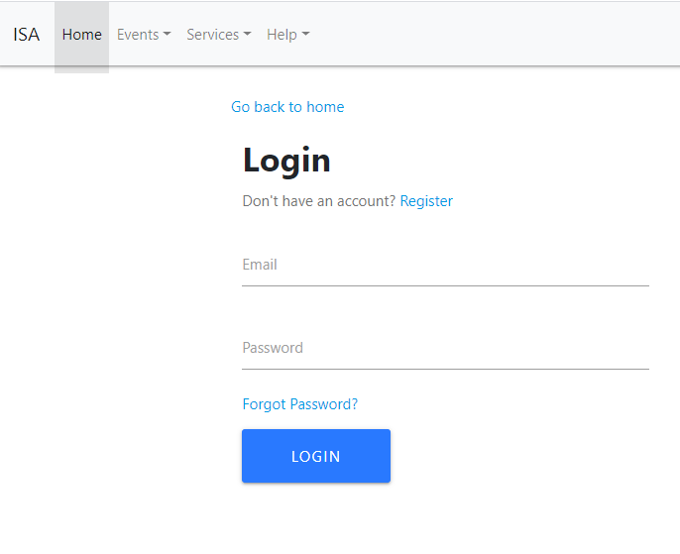
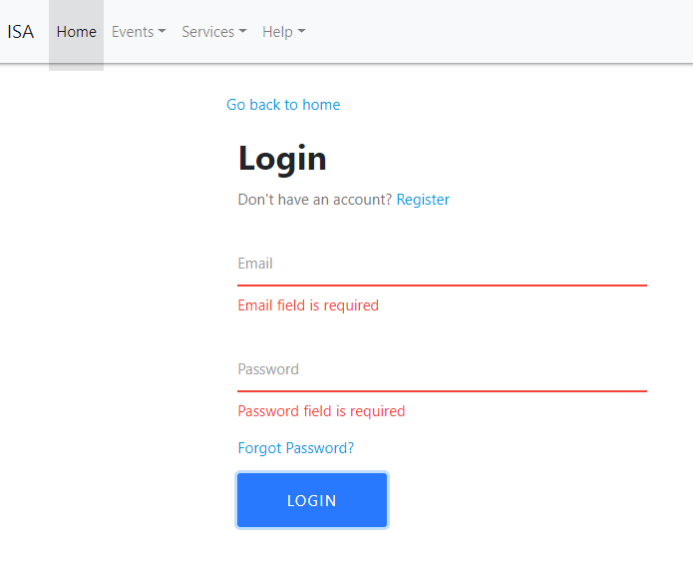
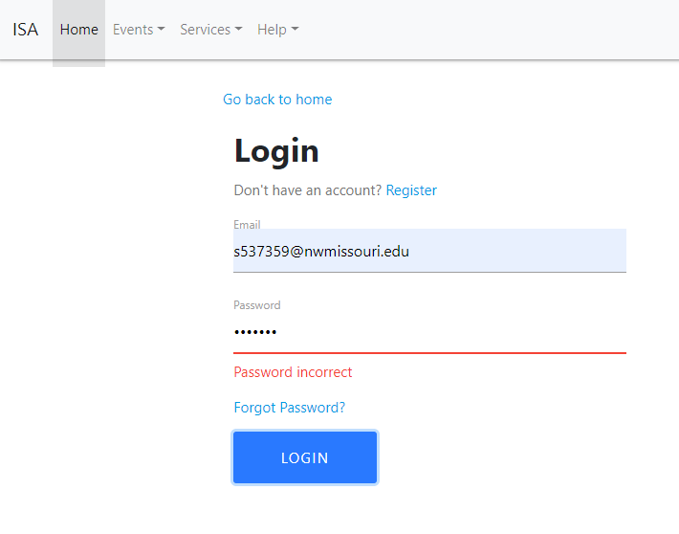
  - Registration Screen: This page is called the Registration page where a user will be able to perform a registration operation onto the application. The user has fields for entering their name, email, and password the user how ever has to re enter their password for safety and making sure he remembers the password and a signup button which, when clicked performs the registration operation. The user should make sure the details provided are correct or else they will be shown an error which is easy to understand.
This page also has a link to navigate back home and a link to login if the user has an accout already. The user will be able a screen which is shown below and errors in user input is also attached.
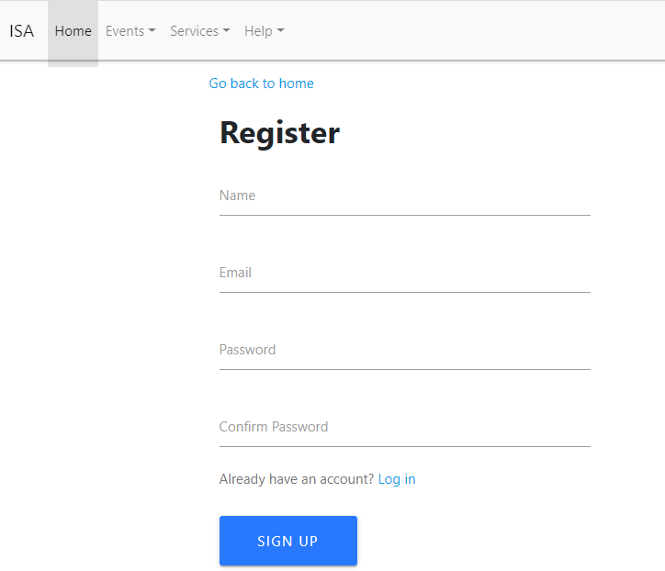
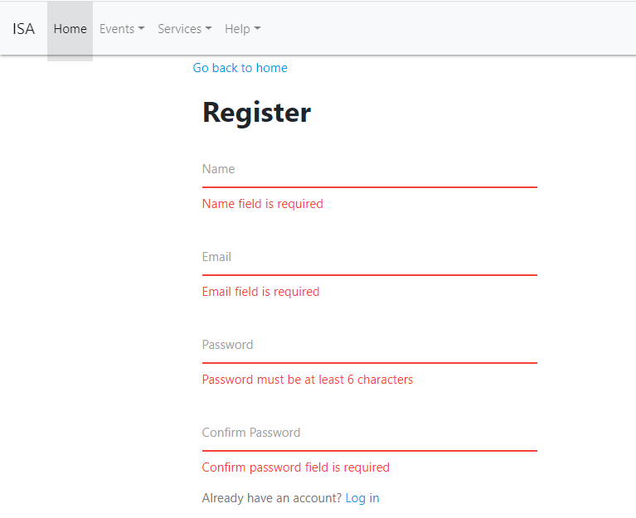
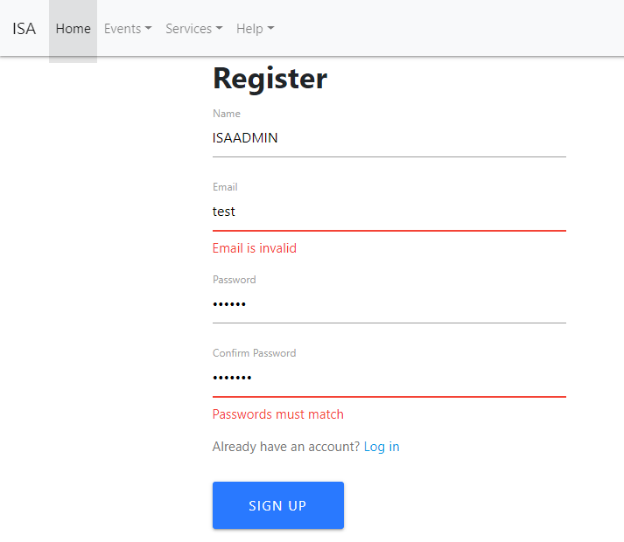
  - Forgot Password Screen: This page is called the forgot password page where a user will be able to retrieve his password. The user has fields for entering their email, and a retrieve password button which, when clicked sends an email to the user’s email with further instructions. The user should make sure the details provided are correct or else they will be shown an error which is easy to understand.
This page also has a link to navigate back to login. The user will be able a screen which is shown below and errors in user input is also attached.
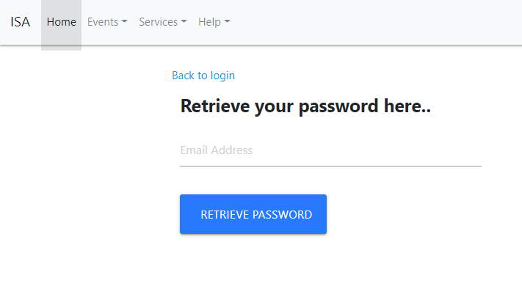
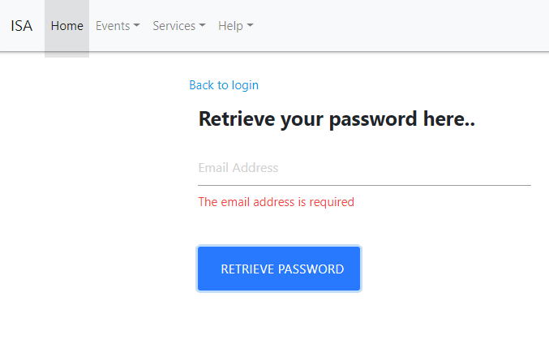
  - Home Screen: This page is the home screen of the application and has a navigation bar for accessing all the pages the web application has in place. The Nav bar looks as below
- Pre Login Home Screen: This is the home screen which the user sees when they are not logged onto the system. Here they will be provide with a welcome note and an option to login or register. The navbar explained above stays constant.
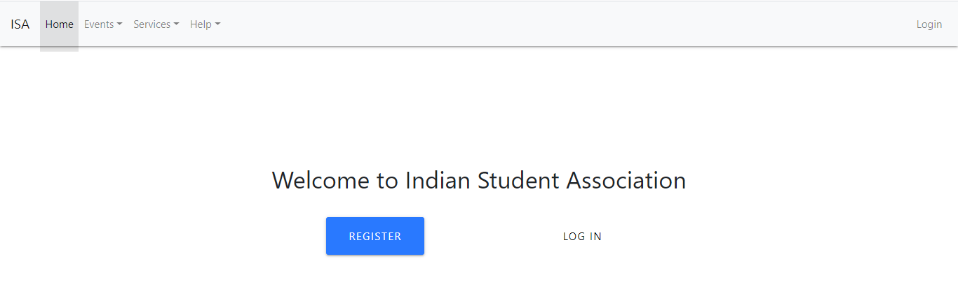
- Post Login Home Screen: This is the home screen which the user sees when they are logged onto the system. Here they will be provide with a welcome note with their name and an option to logout of the application. The navbar explained above stays constant.
